**REFLECTIVE DIARY**

**MSC DATA SCIENCE**

**BUSINESS INTELLIGENCE AND DATA VISUALISATION**

**ADAOLISA PRECIOUS ODOGWU**

**21071028**

**INTRODUCTION**

This report is a step by step documentation and description of all the processes involved in carrying out the Business intelligence analysis and visualization of our group project. Ranging from group formation, tackling and conquering all the set milestones, time stamps, technical and business analysis, visualizations, recommendations, learning outcomes and everything else involved.

**WEEK1**

We were introduced to the module and at this point, no one made any attempt to do any work because we were all still stressed from our exams and coursework from the previous teaching block and we didn’t get any breaks.

**WEEK 2**

This week we had our class and at the end of the class, our group was formed. Oghenemaro, Edwin and Myself came together after class to form the group but we could not find one more person to join so we decided to start work until we found someone else. We tried to familiarize ourselves with what is expected of us by analysing the deliverables, project specifications and also project deadlines. We also chose to use Tableau for our project over power BI. We then decided to familiarize ourselves with the tool. Maro shared a Tableau crash course on Udemy with me since the both of us didn’t have any experience working with it in the past. We decided to meet every week on Wednesdays since this was the days we had our classes. To a large extent, this helped us to implement some of the things we were taught in class in our project .We also decided amongst ourselves to always sit together in class to enable us collaborate and also to have a meeting at the end of every class.

**WEEK 3**

We sat together after the class to finally decide on a project to work on. We discussed the different basis for choosing a project (between the three options given). We compared the different aspects of the projects and went ahead to analyse the milestones and business questions and we compared these too across the three different datasets given.

**WEEK 4**

On wednesday at 4pm we had our first meeting with our industry advisor Dan and we were given an in depth description and explanation of the 12 year guardian league table, the methodology, definition of terms, the structure and method of data collation. Dan works with the Business intelligence team in UWE and today He explained the different metrics to us and their overall percentage weightings, how these metrics were combined to get the guardian scores and finally the rankings. This meeting has succeeded in setting us in the right direction to start our project. After the meeting with our industry advisor, The team had a virtual meeting where we finally looked into the data together and had a brainstorming session on how to work on our milestones.

**MILESTONE 1**

Our first approach was the attempt to get the data clean and ready for analysis. We encountered a large number of missing values in the data. For one, the continuation metric was introduced in 2019 so the value is empty from 2011 – 2018. Initially we thought of dropping the missing values but realized that if we did so, we would be left with little or no data to work with because of the widespread of the times when the continuation values were missing. To solve this we simply replaced those values with zero. We struggled with the data cleaning a bit till one of our classes when one of the tutors gave us insights on python which gave us a structural view of our data and the position of the missing values. This made our data cleaning process a lot easy. Also, for the pre processing of the data we ensured that the data types in the columns are accurate for example, we changed the year data type to date. Also we modelled the data on tableau to create relationships between them. We later discovered that tableau has a function that ignores missing values in datasets.

**Data description**

The guardian league data is sourced from student survey results. The dataset contains the institution level data, subject level data, UWE competitors data, subjects data and institution data. The Guardian league table is organized for 54 subjects in every UK institution from 2011 to 2022. Nine metrics are used to measure the performance and these metrics cut across all phases of undergraduate studies. The subject level data is particularly analysed using these metrics to finally give rise to the data at institution level. The These metrics are briefly described below alongside their percentage weightings;

**Student satisfaction** shows the level of satisfaction of the students with the teaching quality and mode of delivery, their satisfaction with assessment and feedback and the overall course satisfaction. The course satisfaction make up 8% of the overall student satisfaction, satisfaction with assessment make up 8% percent as well while overall satisfaction with course quality make up 4%. All these add up to the 20% weighting for student satisfaction.

**The Average Entry tariff** shows the qualifications that incoming students have and how good those qualifications are before the start of their study in school. This is not the conditions for admitting students and it contributes 15% to the total score of the department

**Student staff Ratio** values are derived by dividing the number of students taking modules in a course by the number of tutors who are available to teaching those modules and it contributes 15% of the score.

**Spend per student** is gotten by dividing the total expenditure for a course by the number of students taking the course. The spend per student ratio is represented on a scale out of 10, 10 out of 10 for most spend and 1 out of 10 for least spend and it contributes just 5% of the score

**Value added score** measures the level of support the departments give the students to enable them achieve good grades, it contributes 15%

**Continuation** shows the number of students that continued with their courses after their first year of study, this also measures how well the departments support the students. It makes us 15% for non medical departments. This metric was introduced to the league table in 2019.

**Career after 15 months** records the number of students in those years who have secured employments after 15 months of graduation and it makes up 15% for non medical courses.

All these metrics add up to 100% of the overall score for the departments.

**WEEK 5**

**Milestone 2**

We met after class to discuss the Business requirements of the data and to identify our stakeholders, we explored the business questions which were outlined in our assignment specifications, we attempted to answer some or all these questions or at the very least, come up with insights on how we could answer them.

1. How has UWE Bristol performed over the period?

2. What factors are at play in explaining UWE’s performance?

3. How have UWE’s subjects fared over the period?

4. What’s next for UWE Bristol in the Guardian rankings? How can we rank higher?

5. How can UWE Bristol perform better in the league table in future, and how can BI support this effort?

6. What factors could be harmful to UWE’s league table position? Are any changes to the league table methodology likely? How would these affect UWE.

It was more or less a brainstorming session as we pondered on what visualizations we could adopt to answer these questions. We tried to analyse how UWE has performed against its competitors and how well they can perform in the future. At this meeting Maro brought up the idea for us to have an interactive dashboard four our visuals so we to help of better understand the direction of trend of our visuals. After the meeting each of us was given one of these business questions to answer using visualizations. On this day, we Identified UWE as our stakeholder.

Note: In week seven after Haixia taught us about choosing our stakeholders, we realised that choosing UWE as a stakeholder was rather a poor choice because UWE is a large Umbrella that houses a lot of other stake holders. We thought of choosing prospective students as our stake holder to enable them in their choice of where to study but along the line we finally settled for the Vice chancellor because He has the power influence the choices of the school. The Vice chancellor looks at the visualizations to see how UWE has performed and makes decisions that help the school make significant improvements in their business strategies. For example, if the business analysis shows that UWE’s low performance in the Engineering field is linked to the fact that they have not made sufficient financial provisions for the students in Engineering department and adequate learning resources have not been made available to them to support their academics and hence the drop in student satisfaction in teaching and overall student satisfaction, The vice chancellor has the authority to influence an increase in spend per student and make more provision for the students. This was also the week Kulwinder joined us because we discovered that she has been randomly assigned to our group

**WEEK 6**

**MILESTONE 3**

At this point we came together to analyse what we have done and which of our visualizations were fit to make it to our dashboards. We decided to represent the different changes over time with line graphs as it gives a clear visualization of changes over time.

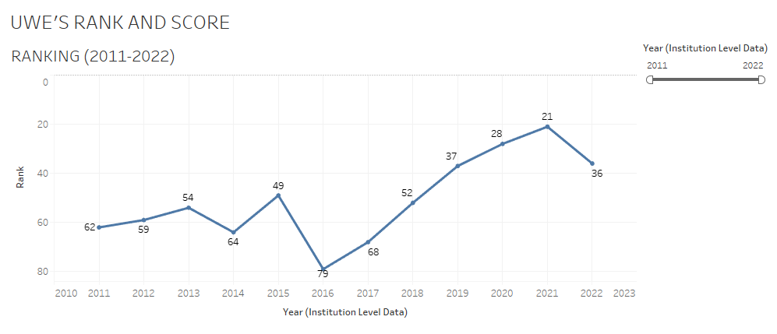

From the graph above we clearly see UWE’s performance over the years from 2011 – 2022. In recent times, UWE has performed exceptionally well after they hit rock bottom in 2016 when they ranked 79. That has been the all time low within the years covered by our data. For 5 consecutive years after 2016, UWE recorded an increase in rank. According to the Guardian league table methodology, a lot of schools recorded very poor performances. This is arguably as a result of the post covid effects on the academic system but even in 2021, UWE ranked so high and that was the year UWE attained its highest rank (21 in the UK).

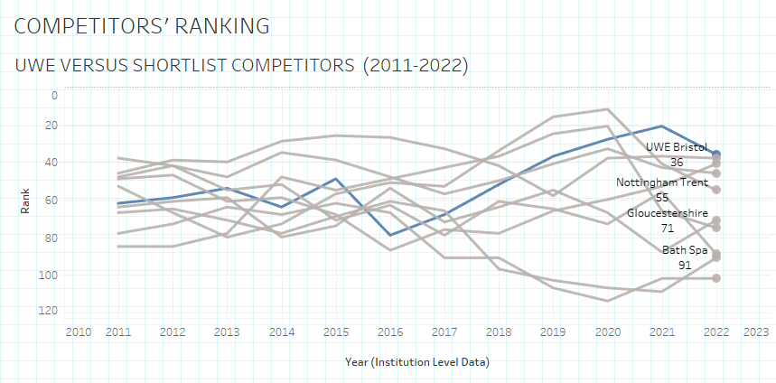

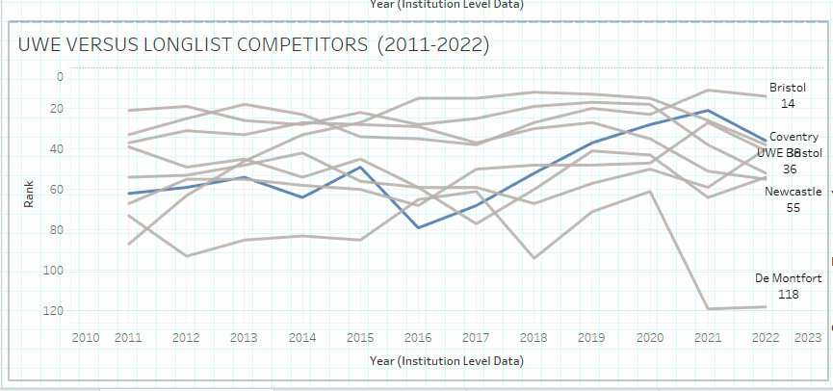

We also compare UWE against their longlist and short list competitors. UWE is represented by the blue line on the graphs. From this we see that their high performance from 2017 also superseded the performance of its competitors. In 2021 UWE performed the highest among its short list competitors and came second after University of Bristol among its long list competitors.

We also compared how UWE has performed in the individual metrics with the performance of its competitors in the graphs below and we can see that there was a huge decline in UWE’s general average entry tariff from 2017 to 2018 where it remained constant at that level till 2022. In spend per student, there was a slight increase which made UWE rise above bath spa, Nottingham Trent, Plymouth, Brighton and Bournemouth. UWE graduates have maintained the highest Career prospects after 15 months of graduation for 11 years among their counterparts in the shortlist competitor institutions.

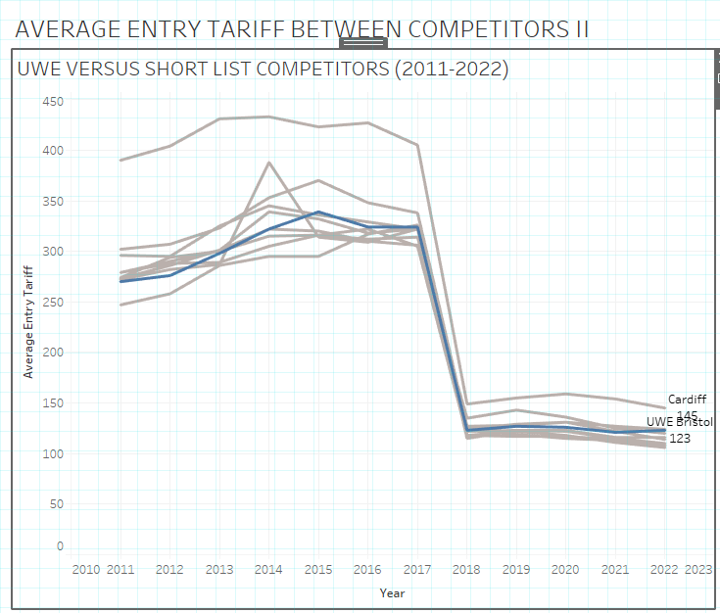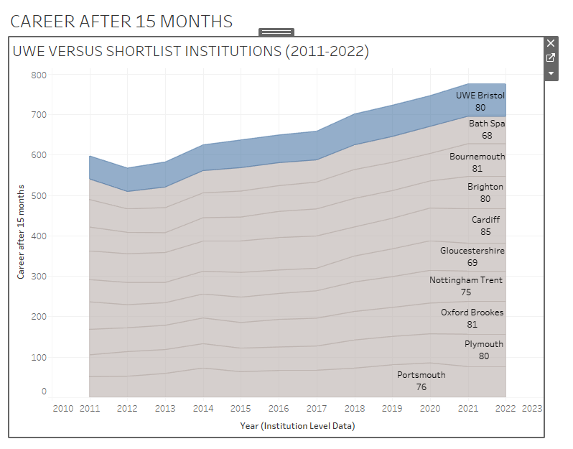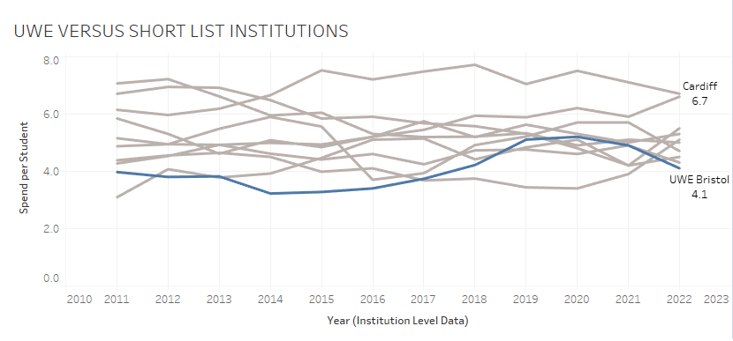

**WEEK 7**

**MILESTONE 3**

We continued analysing our visuals and tried to figure out how best we can put things together with regards to viewing UWE’s performance from a business perspective to answer certain business questions. This week we learnt about accessibility in class and how we can present our visuals in such a way that they accommodate visually impaired individuals, we made some adjustments to the colour variations, density and we tried to label them appropriately. From the overall UWE ranking, we see that UWE’s rank dropped in 2022 after going up for 5 consecutive years. For this reason we would be looking at some of the metrics in the year 2022 to help us identify some setbacks experienced in 2022 and how we can make recommendations towards improvement. We analysed question 2 by identifying factors that play significant roles in UWE’s performance (Question 2). Last week we compared UWE’s performance against that of the shortlist competitors. We identified that these metrics add up to form the overall institutional performance and finally the rankings. This week we created a dashboards that gave us insight on how UWE has performed across all the metrics, we also look at how the subjects have performed at institution level. Later that week we met again with our industry advisor and He answered some questions that people in other groups had.

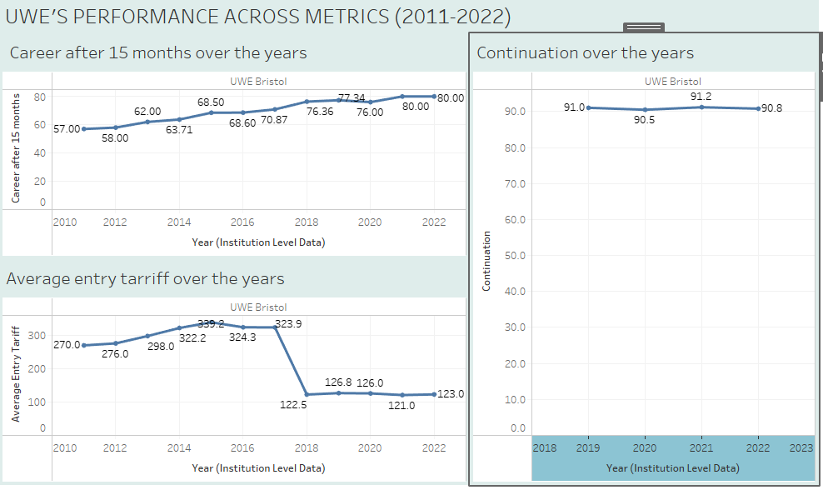

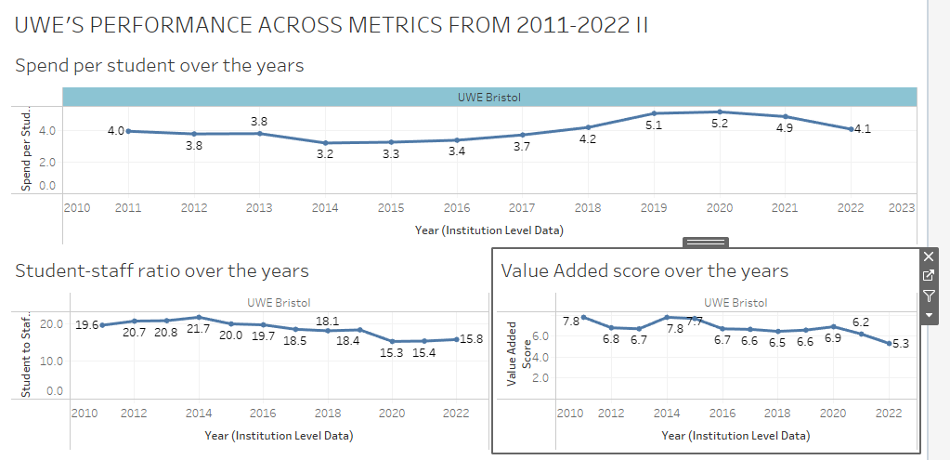

The above dashboards show that UWE has managed to remain consistent in all the metrics with very slight increase and decrease over the years. This is seen across all the metrics except for the average entry tariff where there was a huge decline between 2017 and 2018 and from 2018 to 2022 UWE has not risen above that level again.

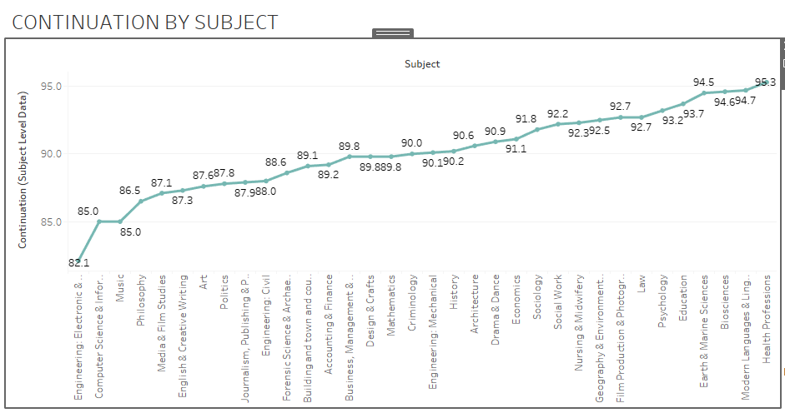

From the Guardian league table methodology we see that the students in the medical profession have the least tendency to discontinue their studies in their first year. The Subject with the highest continuation rate among non medical subjects is the modern language and linguistics department and the lowest is the engineering department

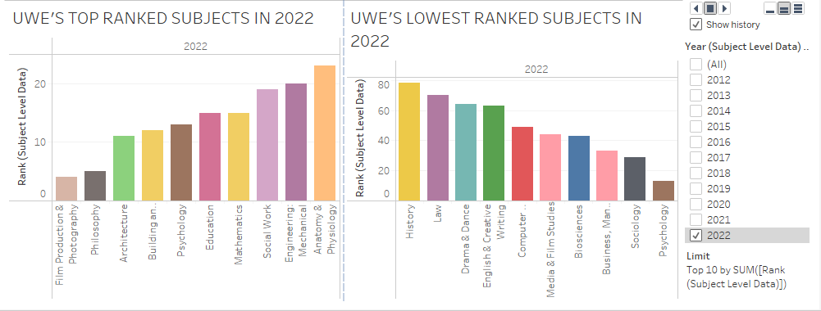

We also selected the year 2022 and analysed how the subjects have ranked in the year and we see that Film psychology ranked highest while History ranked the lowest. More attention has to be paid to these subjects with low rankings.



We also plotted a second visual that showed us the highest subject rankings across all the years for UWE. We see that earth and marine sciences and building and town planning have both ranked the highest for four years each making them the highest performing subjects while Psychology, journalism have both managed to rank the highest in 2022 and 2018. In 2021, there was a tie between Mathematics and Philosophy and they were both ranked the highest in that year. It is important to draw our stakeholder’s attention to Architecture which has shown significant improvements over the years.

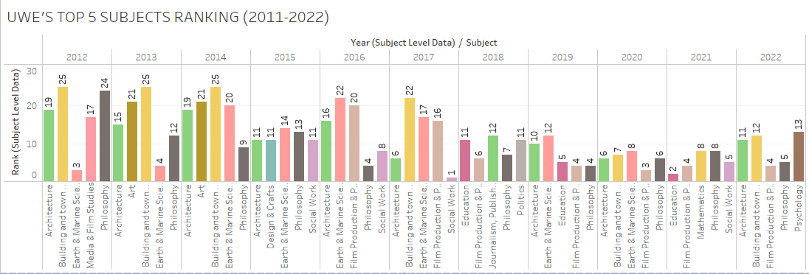

**WEEK 8**

**MILESTONE 3 CONTINUED**

The expenditure in every department is an important attribute to explore and improve when making decisions to improve UWE’s reputation based on ranking in the league tables.

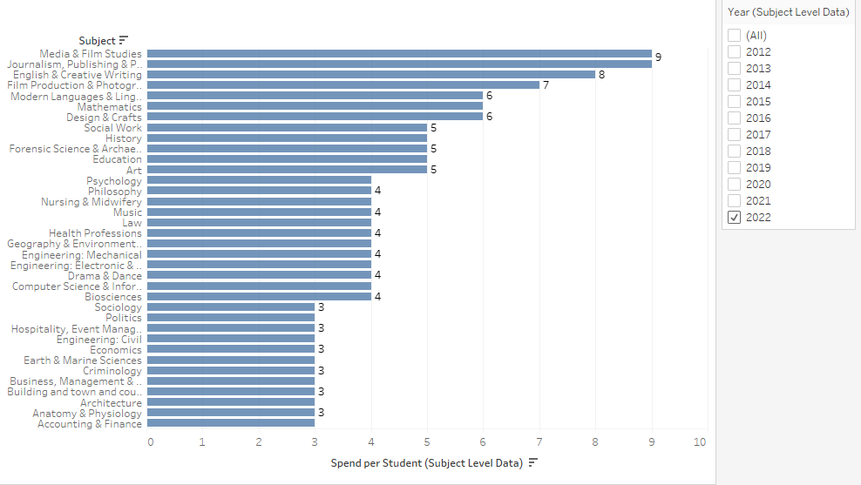

We analyse the expenditure at subject level for the year 2022. As we know, the spend per student is expressed on a scale out of 10, 1 out of 10 being the least expenditure and 10 out of 10 being the highest expenditure.

**WEEK 9**

MILESTONE 3 CONTINUED

We came up with the idea to try to analyse how the ranking is influenced by the different metrics. To tackle this we plotted the correlation graphs of all the metrics against ranking for UWE. The graphs are shown below.

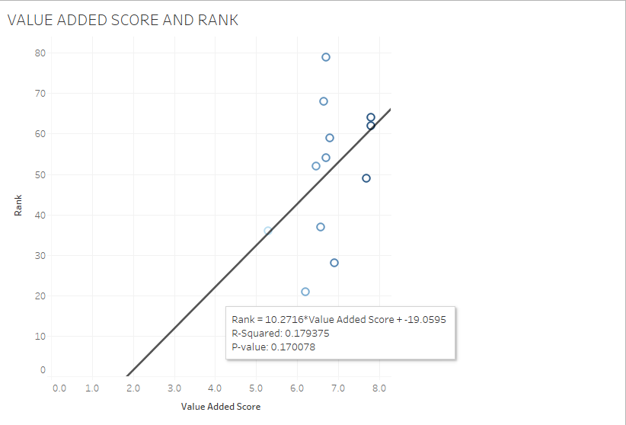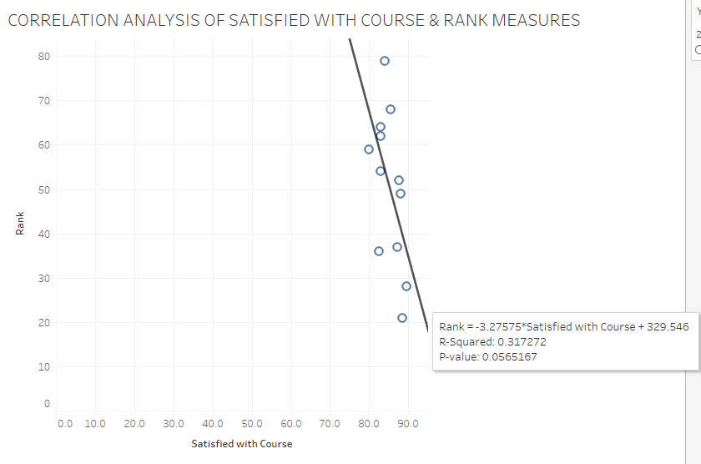

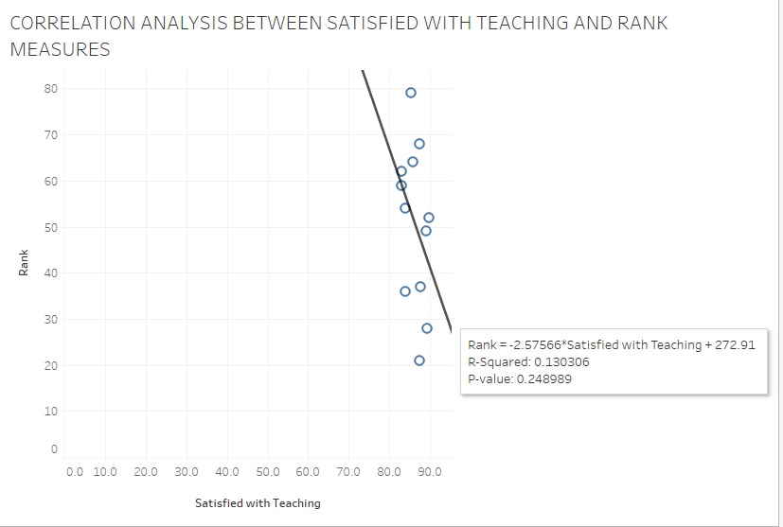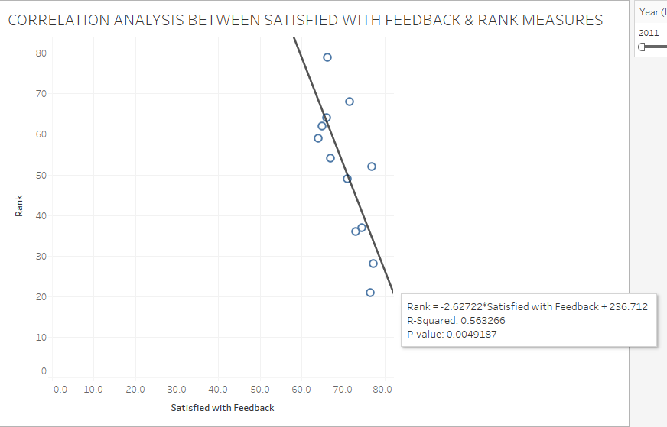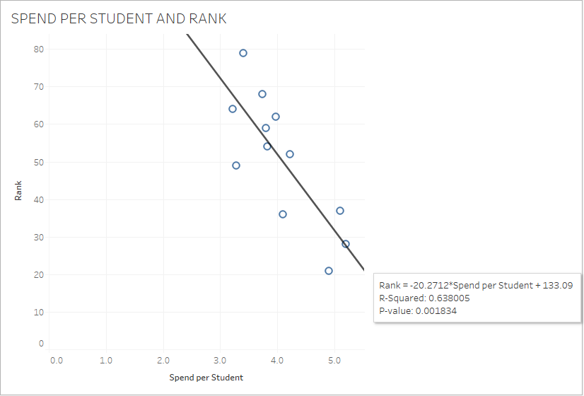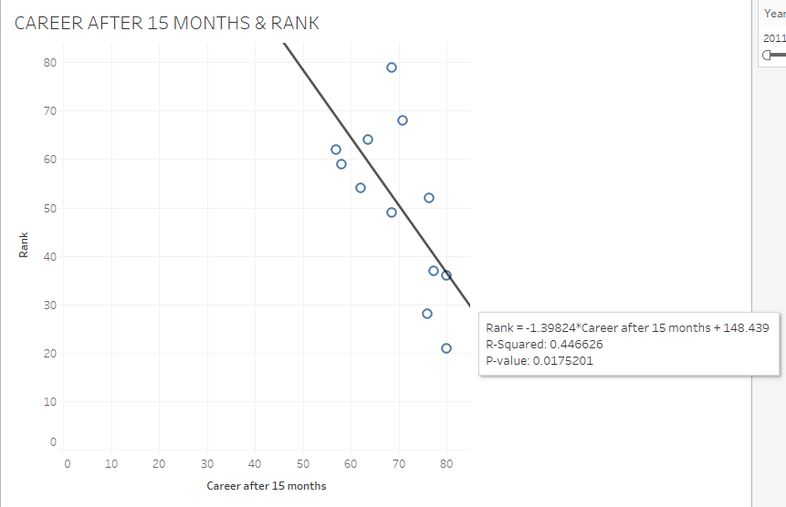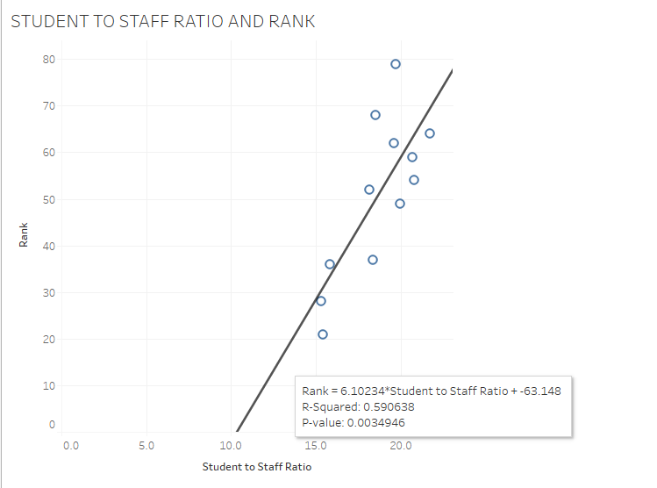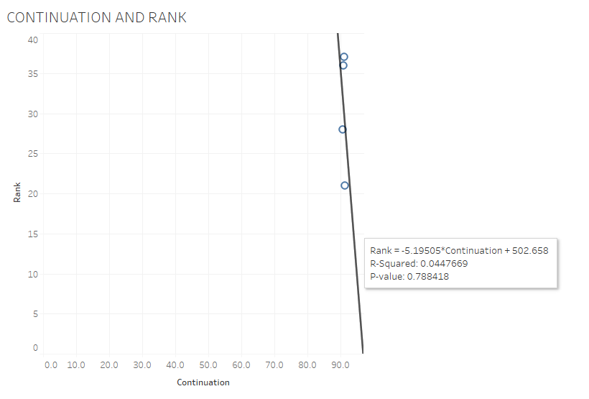

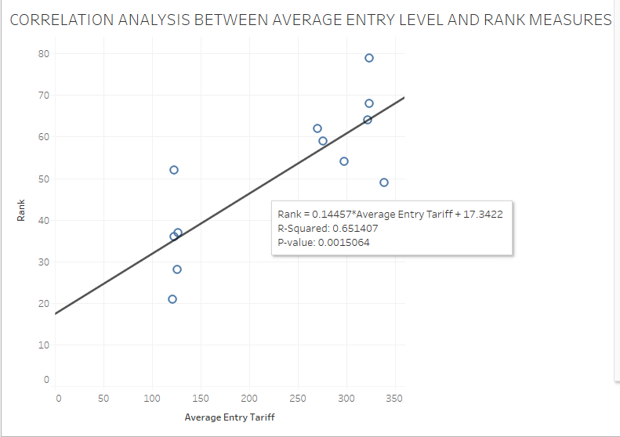

SUMMARISING THE CORRELATION GRAPHS

The most significant observation would be the correlation between course satisfaction and rank. Course satisfaction has a negative influence (-3.375) which means that the higher the satisfaction level the higher the rank value (And we know logically that the low rank values actually represent High rankings for example, An institution with a rank of 1 is higher in the league table than an institution with a rank of say 50 regardless that 50 is a higher number.) This is a very important point to note. Also we use the r-square value to see the percentage impact or influence of the metrics on the institution ranking. From this, average entry tariff has an r-square value of 0.651 which translates to 65.1% influence and that is the highest influence on institution rank while satisfied with teaching which has a percentage impact or influence of 13.03% on ranking has the lowest influence. Other metrics with high impacts which should also be paid close attention to are; spend per student, 63.8%, student to staff ratio, 59%, satisfied with feedback, 56.3%.

**WEEK 10**

Our work was so scattered and we needed to try to make some sense out of the work we have done so far. We met about twice this week as we were drawing very close to the submission deadline. We managed to put our dashboards and stories together.

**MILESTONE 4**

At this point we have succeeded in completing all our dashboards and have put them all together in an order that answers all the business questions. This section gives a deep insight to our stake holder (The vice chancellor) and will enable them in making decisions that will make UWE perform better in the future.

I would say that UWE has had a rather impressive performance over the years, first we see that UWE performed the highest in 2021 and the lowest in 2016 when they ranked 79. It is also impressive to note that UWE has worked so hard to remain in the top 100 schools in the UK for 12 years out of 165 accredited schools. Also, UWE had the highest guardian score in 2019. UWE has a list of long and short list competitors, the Long List competitors are the schools that have similar structure with UWE by structure, they have similar student count, staff count, offer similar subjects etc. The short list competitors are those institutions that are applied to by students alongside UWE. This means that They are the schools which a prospective student will most likely apply to if they apply to UWE. In our interactive charts we compared UWE’s rankings with the Long and Short list competitors and we see that among the short list competitors, UWE maintained top 6 position until 2016 when they dropped so low to 9th position. In 2021 and 2022 they ranked the highest. Among the long list competitors, they haven’t performed so well until 2021 and 2022 when they came second after university of Bristol. UWE was actually the lowest in 2016.

Based on our correlation, we have seen those metrics which have high impacts on rank, We also need to look at these metrics critically and compare them to UWE’s competitors. We know that Average entry tariff has the highest impact and thus we compare UWE’s average entry tariff against that of its competitors. UWE performed better than 3 schools in the long list competitor list although from 2015 they have recorded a significant improvement and have been one of the highest among the short list competitors. The next on the impact list is the spend per student and in this aspect I would say that UWE needs to look into this critically as they haven’t performed so well among both their shortlist and long list competitors. There is a huge possibility that the spend per student plays a massive role in the poor performance of UWE’s subjects especially the STEM ones. Among short list competitors UWE have had the highest employment rate the entire decade, from 2011 to 2022 whereas they were the lowest in 2011 and in 2021 and 2022 when they performed the highest based on career prospects, they only managed to supersede Northumbria, De Montfort and Huddersfield. We have also analysed how UWE’s subjects have performed over the years. For the correlation analysis we have in depth insight from week 9 where we discussed the individual relationships between the metrics and the Rankings in details. In the correlation, the continuation is also considered and we see that students in Health sciences, languages, biosciences, earth and marine sciences, Education, psychology law and environmental sciences recorded the highest continuation rates while students in Engineering, computer science, music, philosophy, media and film studies, creative writing, art and politics performed the least. Some of these courses with low continuation rates also have very low spend per student rates as well. Also we have compare subjects based on continuation and rankings. Subjects like English and creative arts have low continuation rates and row rankings while subjects like Film production and photography have high continuation rates and high rankings. UWE can carve a niche for itself strategically with the Architecture and Philosophy because they are continually taking the lead every year in ranking. Finally, we came up with summary visuals which gives an overview of UWE’s performance over the years at institution level. This final visual points out those metrics that have had significant changes over the years and would also drive decision making.

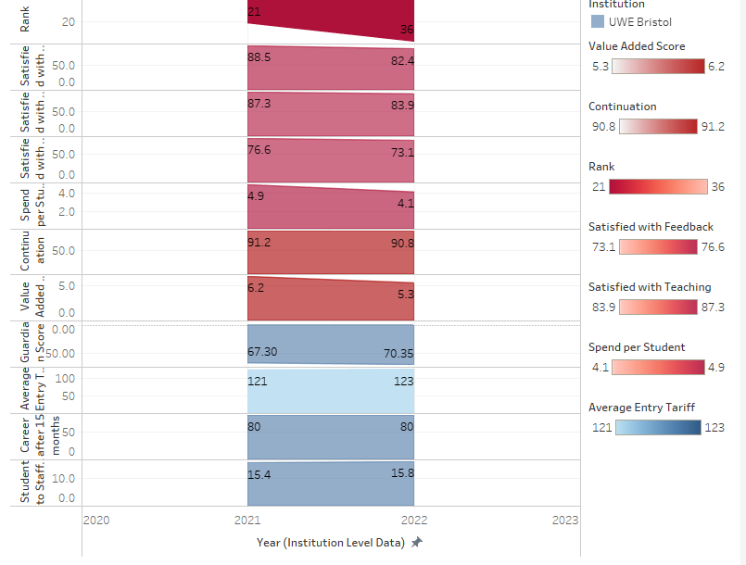

**WEEK 11**

This is our final week and we have come together to put all our findings together to draw up recommendations for our stakeholder. Our submission deadline is next week and we are a bit choked up with a lot of work from other modules as well.

**MILESTONE 5**

**RECOMMENDATIONS**

We have critically carried out all our analysis and we have drawn up recommendations and insights on how UWE can perform better. From the comparative analysis between UWE and the short and long list competitors we see that UWE performs exceptionally well among their short list competitors so it is safe to say that UWE has outgrown such comparisons. It has to be stretched beyond its limits. It is important that UWE is challenged to do better by being compared more with their long list competitors and if it wishes to be more ambitious, It should broaden its scope to try to match even the Russel group schools. It is important to study these elite schools to know what they do differently and how to do it better. For the Subjects that have low continuation rates like engineering. We advice that adequate support is provided to them to ensure a hassle-free learning environment for students. Also, we have seen that certain metrics have high impacts on the institution rankings, it is important that the school becomes more strategic about making improvements in those metrics especially the Average entry tariff and spend per student. UWE also needs to build its strength in certain subjects which have recorded significant progress over the years, subjects like Architecture. The school also needs to consider proper financing of the different departments especially the STEM ones.

**LIMITATIONS**

We had a few set backs in our work. Initially we struggled to pick a project to work on because we tried so hard to understand the datasets and specifications for the projects. Also we had difficulties cleaning the data we had to send Haixia emails seeking help. Also we were behind schedule with deliverables and task most times because we also had other projects in other modules. During our meetings, we were not always all in attendance as each one of us at some point had other matters (personal and otherwise) to attend to so it required that we had to fill each other in on meeting outcomes at intervals.

It took us a while to fully understand the guardian league table methodology and to be honest I still don’t fully understand some aspects of it yet. All thanks to Dan who clarified some things to us and was always available to answer our questions, It’s nice to know that we were not alone, we had help every step of the way.

Finally, There was a little confusion in our project deadline which gave us little time to complete our project so we had to struggle a bit at the end to meet up.

**LEARNING OUTCOMES**

This project has given me the opportunity to gain first hand experience in Business intelligence analysis and data visualization with Tableau. I also learnt to create interactive visuals on tableau Also, I have developed interpersonal, effective communication, conflict resolution and collaboration skills from working in a group. I have also familiarized myself with certain principles of project management, time management and report writing. This project had broadened my knowledge of what to expect in a real world scenario. In the course of this work I have been able to apply critical thinking and have hence gone a step forward in developing analytical and problem solving skills.

**REFERENCES**

the Guardian. (2021). *Methodology behind the Guardian University Guide 2022*. [online] Available at: <https://www.theguardian.com/education/2021/sep/11/methodology-behind-the-guardian-university-guide-2022>.

‌ Hazelkorn, E. and Mihut, G. (2021). *Research handbook on university rankings : theory, methodology, influence and impact*. Cheltenham ; Northampton, Ma: Edward Elgar Publishing.

‌